Week 3 – Virtual Machine Deployment
Virtual Machine Creation
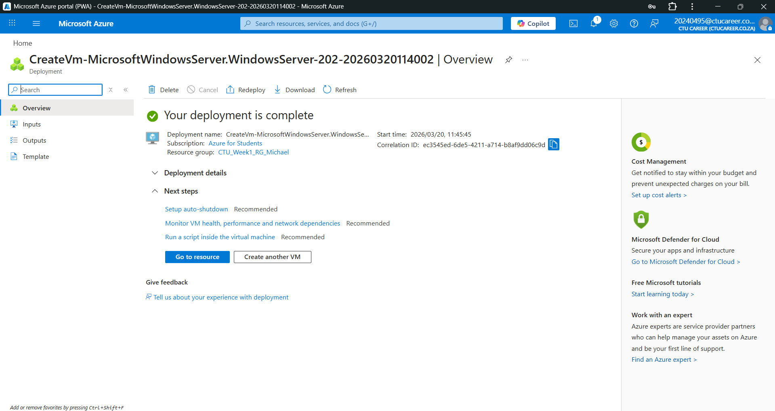
A virtual machine named CTU_VM_Michael was deployed in Azure using the B1s size. The virtual machine is running Windows Server 2025 Datacenter and is used to support the CTU Training Solutions environment.

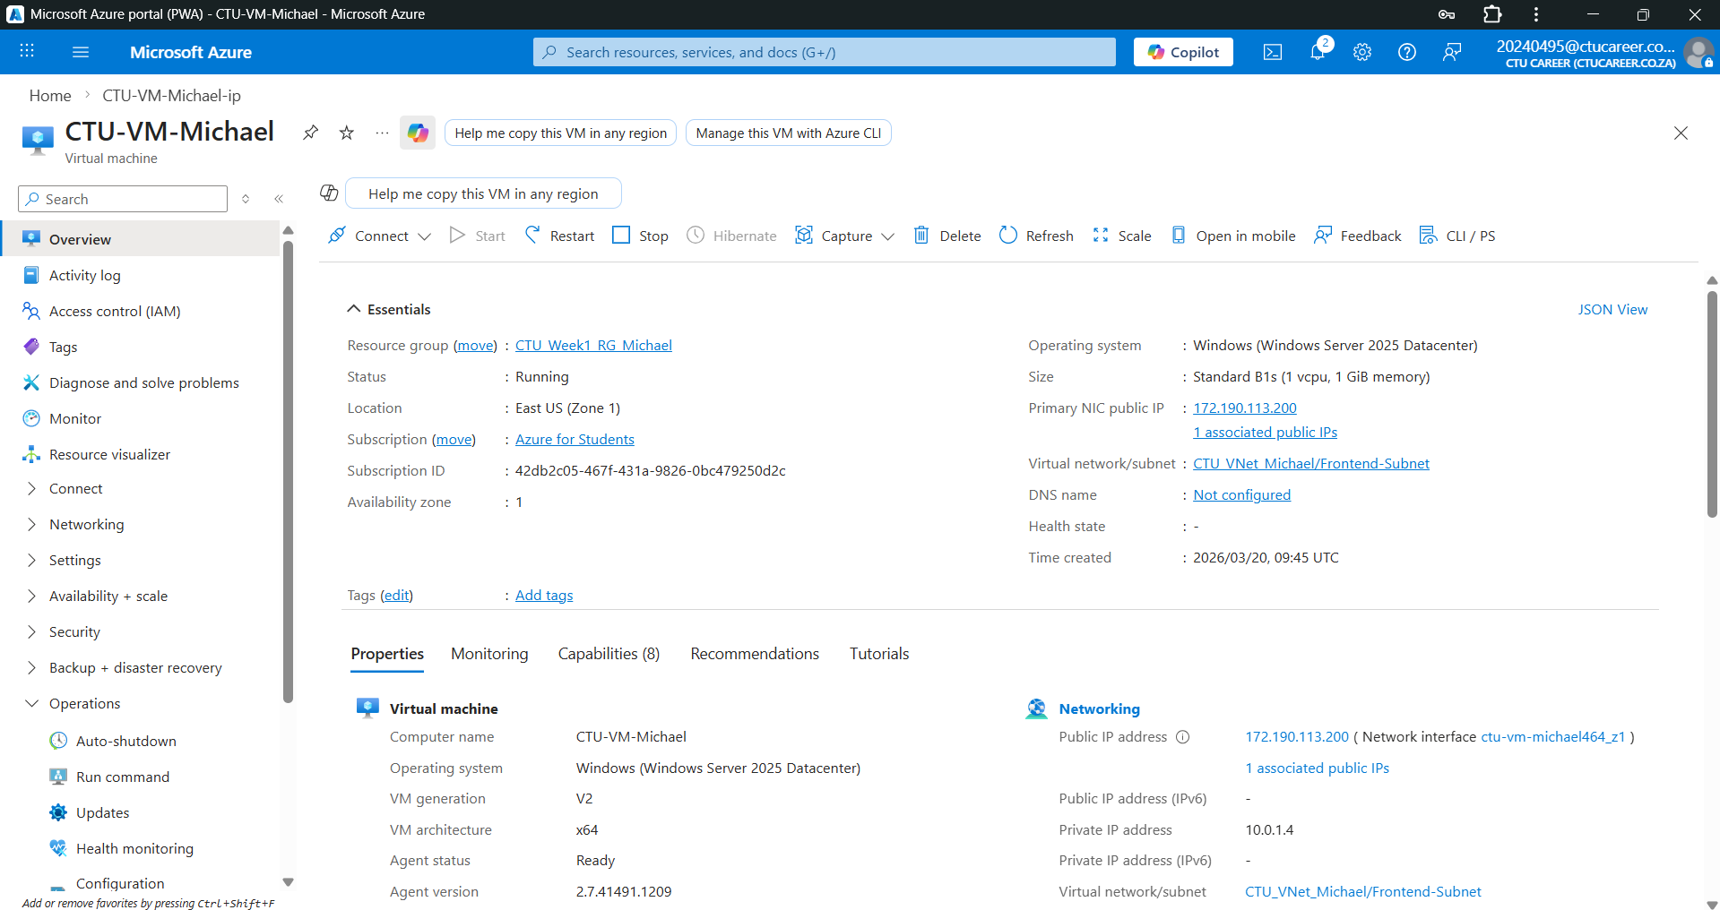
Auto-Shutdown Configuration
Auto-shutdown was enabled on the virtual machine and set to 19:00 daily to reduce unnecessary resource usage and costs.
Networking Configuration
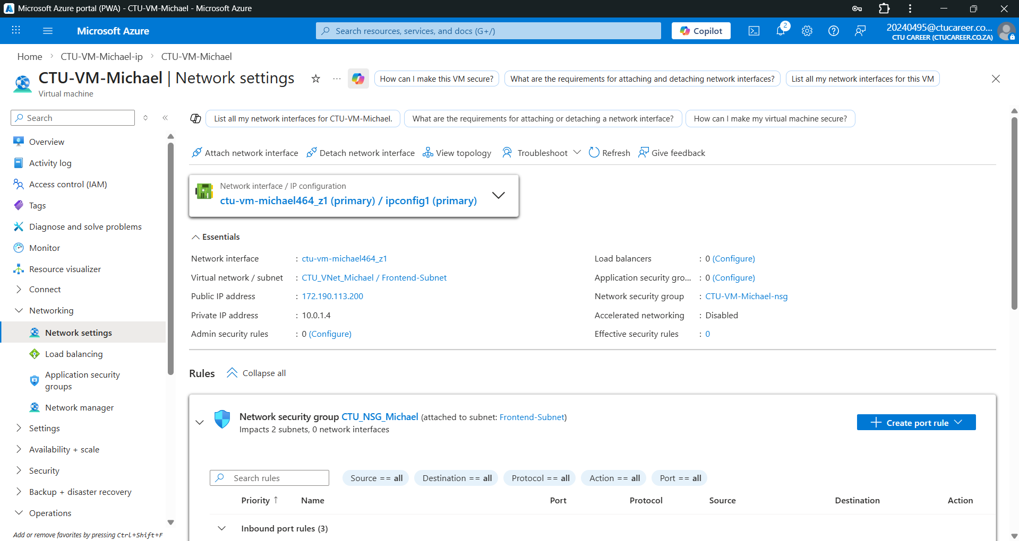
The virtual machine was connected to the CTU_VNet_Michael virtual network and placed in the Frontend-Subnet (10.0.1.0/24). A public IP address was assigned to allow remote access.
Security Configuration
Remote Desktop Protocol (RDP) on port 3389 was enabled to allow secure remote access to the virtual machine.

